
In vitro fermentation technique to evaluate feeds of goats
Africa Journal of Animal and Biomedical Sciences 8(1), 2014
ISSN: 1819-4214
©INABSTA
By
K.O. Lapenga.
Department of Livestock and Industrial Resources.
College of Veterinary Medicine & Biosecurity
Makerere University, P.O. Box 7062, Kampala.
Email: lapenga@covab.mak.ac.ug / kenolapenga@gmail.com

Abstract

A study was done to evaluate banana peels, maize bran, cotton seed cake, Leucaena leaves and elephant grass for energy as feeds for goats, using in-vitro fermentation technique. The in-vitro media solution was prepared and fermentation bottles were prepared using 12 culture screw bottles, with a valve and connected to a teflon tube to allow fermentation of gas within the bottle to flow out and be measured. Rumen fluid (10ml) was used to inoculate substrate in all fermentation bottles, each containing 0.5 g of each sample including the blank under a continuous carbon dioxide flux. The bottles were incubated in the water bath at a temperature of 38⁰C for 168 hours. The gas volumes were measured by displacement of water in a 100 ml measuring cylinder suspended in a water trough. The cumulative gas production was determined by subtracting gas from the blank and the results plotted against time of incubation. The cumulative gas volume was associated with increase in bacterial activities in the rumen indicating the rate of degradation of the feeds. The result showed that maize bran, banana peels and elephant grass were primarily energy feeds in respect order of importance, while cotton seed cake and Leucaena leaves had the lowest levels and rate of gas production.

Key words: Evaluate, fermentation, cumulative gas volume, incubation, in-vitro media solution, substrate.

Introduction

Goats in Uganda are reared by tethering and sometimes are left to roam on their own especially in the dry seasons when crops have all been harvested (1). However, in the densely populated regions especially on the slopes of Mt Elgon in Eastern Uganda, where land is very scarce, goat farmers feed their animals mainly on banana leaves and potato vines in addition to grazing on hedges. It was doubtful if these feeds could meet the maintenance requirements of the goats for energy and digestible protein. It was against this background that the rational use of crop residues and agro-industrial by-products were empirically validated and extensively documented as feed resource that could be used to improve the productivity of goats (2, 3). In Uganda Banana Peels (BP) crop residue, Cottonseed Cake (CSC) and Maize Bran (MB) are agro-industrial by-products that could supply readily fermentable carbohydrate and energy needed for increasing growth rate in goats. While the values of cotton seed cake and maize bran were known and commonly used, the nutritional value of banana peels for goats had received little attention. A novel approach of using in vitro rumen fermentation technique (Menke et al., 1979) for evaluation of the nutritional quality of the feed resources that can be used as supplements for goat nutrition was undertaken.

Materials and methods

The in vitro media solutions were prepared according to Goering and Van Soest (4). Fermentation bottles were prepared by using 12 (250ml) culture screw bottles. Holes of 1.2 cm in diameter were drilled through the caps of each bottle through which a valve cut from an old inner car tube was filled. This was connected to a teflon tube of about 6 cm to allow fermentation gas within the bottle to flow out and be measured. The teflon tube was regulated by placing a clip which could be opened and closed as desired whenever the gas was measured. This arrangement was used in the absence of a gas syringe.

Oven dried samples (5g) (at 60⁰C for 48 hrs) of maize brand, elephant grass, banana peels, cotton seed cake and Leucaena leaves ground to pass through 2mm screen were used as substrates. Rumen fluid was obtained from a fistulated cow by using a vacuum pump which sucked both the fibres and rumen fluid at a rate of 2.0 cubic metres per hour into the jar full of carbon dioxide. Fibres were collected in the rumen to obtain great quantity of fibre digesting micro-organisms which are normally attached to fibres.
The top layer of the rumen fluid was discarded and the bottom layer (with fibres) was blended in a Waring blender for 3 minutes. The rumen fluid was then sieved three times through cheese cloth into a beaker maintained under anaerobic condition affected by a continuous flush of carbon dioxide. 0.5 g of each feed sample was weighed and added into the fermentation bottles in duplicate. Two bottles without the substrate were used as blank. Forty mls of the in vitro solution was added into each fermentation bottles including the blank. Rumen fluid (10ml) was measured and used to inoculate substrate in all the fermentation bottles including the blank under continuous carbon dioxide flux. The bottles were sealed and incubated in the water bath at a temperature of 38⁰C for 168 hours.
Gas volumes were recorded at interval of one hour in the first 10 hours and then at intervals of 4 hours up to 168 hours of incubation. The gas volumes were measured and recorded by displacement of water in a graduated 100 ml measuring cylinder suspended into a water trough. The cumulative gas production from fermentation was determined by subtracting gas from the blank. The results were plotted against time of incubation. This experiment was done three times.

Results

Cummulative in-vitro gas production of elephant grass, banana peels, maize bran, cotton seed cake and Leucaena leaves were as shown in Fig.1.

Fig.1.. Cummulative in-vitro gas production of elephant grass, , banana peels, maize bran, cotton seed cake and Leucaena leaves

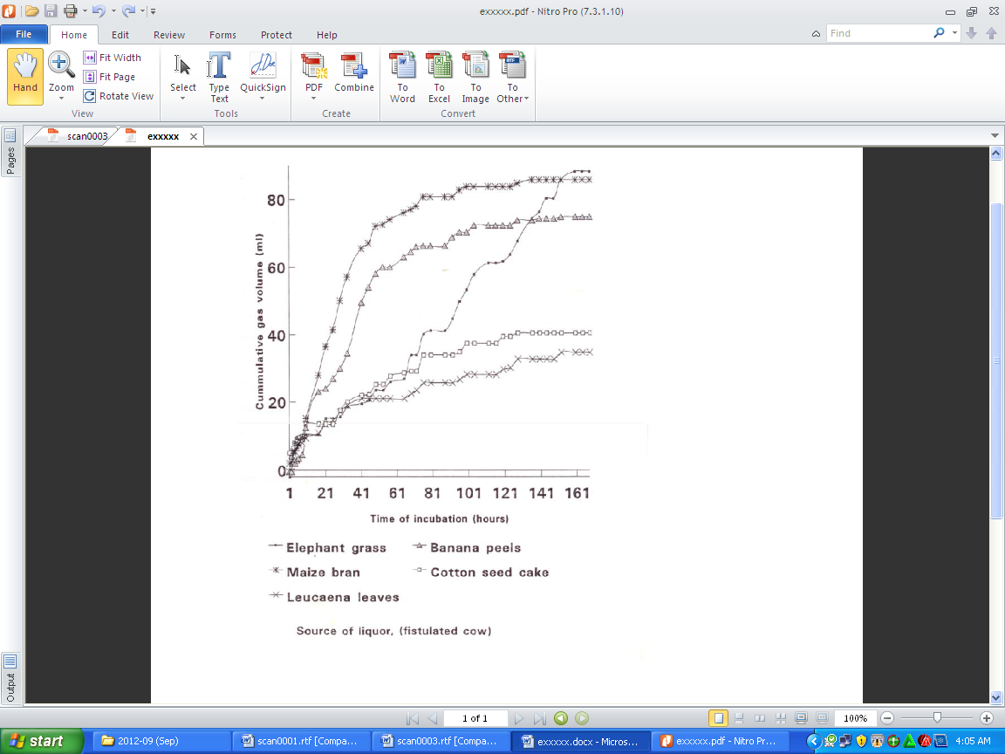

Discussion

In this study gas production was used as a measure of energy metabolized by rumen micro-organisms indicating the extent of utilization in the rumen (5). The cumulative gas volume was associated with increase in bacterial activities in the rumen indicating the rate of degradation of the feeds. Fig. 1 indicated that maize bran (MB), banana peels (BP) elephant grass were primarily energy feeds in respective order of importance. In this respect cotton seed cake and Leucaena leaves had the lowest levels and rate of gas production. The curvilinear trends observed in all the feeds were similar to curves that depict organic matter disappearance in nylon bag in the rumen (6). Typical curves had earlier been obtained with browse species (7) and straw (8). Theodorou et al. (9) indicated that gas volume was associated with increase in bacterial activities in fermentation cultures with a typical trend observed in maize bran and banana peels; however this was not clearly depicted with cotton seed cake and Leucaena leaves. The result clearly showed that maize was readily fermented indicating increased activities of the sugar fermenting micro-organisms because of the readily available energy present and low fibre content of the ration. Low nitrogen content in banana peels was a critical constraint (10). However, this can be compensated for, by high digestible energy in banana peels believed to be a costly (11) and critical (3) nutrient in goat production.

In conclusion, the in vitro fermentation technique in which gas production was measured has the advantage in that a large number of feed resources can be screened. Hence it could help in the development of feed supplements using locally available feed resources. In this study, low fibres, succulence and rapid degradation in the rumen were factors that promote intake of banana peels and hence both maize bran and banana peels could be suitable candidates in the feed inventory as supplements for the supply of energy for goat nutrition.

References

- Okello, K.L., Obwolo, M.J. 1984. Uganda: Review of the potentialities of goat production. World Animal Review, 53: 27-32. Fische No. 85501201. http:/www4.fao.org/cgi=253591.
- Kayongo, H., Said, A.N. 1986. Use of INFIC Nomenclature on Crop Residues and by-products Produced in Kenya. In: Preston, T.R. and M.Y. Nuwanyakpa (Eds). Towards Optimal Feeding of Agricultural By-products to Livestock in Africa. Proceedings of a Workshop Held at the University of Alexandria, Egypt October 1985. Published by ILCA at Addis Ababa, Ethiopia. http://www.fao.org/Wairdocs/ilri/x5487e06.htm.
- Mtenga, L.A., Kitaly, A.J. 1990. Growth performance and carcass characteristics of Tanzania goats fed Chloris gayana hay with different levels of proteins supplements. Small Ruminant Research, 3: 1-8.
ISBN = 1845938496.
- Goering, H.K., Van Soest, P.J. 1970. Forage Fibre Analysis. Agriculture Handbook, 379. Agriculture Research Service, United States, Department of Agriculture (USD), Washington DC USA, pp 1-8. www.foragelab.com/resources/l abProcedures.cfm
- Menke, K.H., Raab, L.,Salewski, A., Steingas H.F.D., Scheider, W. 1979. The estimation of the digestible and metabolizable energy content in ruminant feedstuff from the gas production when they are incubated with rumen liquor in vitro. Journal of Agricultural Science, 93: 217-222.
http://ar.newsmth.net/att/18794deac98939/S0021185900086305a.pdf
- Mehrez, A.Z., Orskov, .E.R. 1977. A study of the artificial fibre technique for determination of the digestibility of feeds in the rumen. Journal of Agricultural Science, Cambridge, 88: 645-649.
www.fao.org/docrep/ARTICLE/AGRIPPA/570_EN-04.htm.
- Ebong, C. 1989. The nutritional effects of tannins and related polyphenols in bird resistant and non-bird resistant sorghum varieties and legume browses. PhD thesis of Aberdeen (U.K.). www.journals.elsevierhealth.com/periodicals/livest/.
- Blummel, M. 1988. The nutritive value of left straw and the methods of its assessment.
MSc. Thesis University of Aberdeen (U.K.). www.hua.edu.vn/khoa/cnts/index.php
AB21 9SB
- Theodorou, B.A., Williams, M.S,, Dhanoa, A., McAllan, A.B. 1991. A new
laboratory procedure for estimating kinetic Parameters associated with the
digestibility of forage. In: International Symposium of Forage cell wall structure
and Digestibility, Oct. 7-10 1991, Held in Madison Wisconsin USA.
- Lapenga, K.O., Ebong, C., Opuda-Asibo, J. 2009. Growth performance and feed utilization by intact male Mubende goats fed on various supplements with elephant grass (Pennisetum purpurreum) as basal diet. UgandaJournal of Animal and Veterinary Advances 8 (10): 1999-2003. ISSN: 1680-5593
- Luo, J., Goetsch, A.L., Nsahlai, I.V., Johnson, Z.B., Sahlu, T., Moore, J.E., Ferrel, C.L., Galyean, M.L., Owens, F.N. 2004. Maintenance energy requirements of goats: Predictions based on observations of heat and recovered energy. Small Ruminant Research, 53(3): 221-230. DOI: 10.1016/j.smallrumres.2004.04.009. linkinghub.elsevier.com/retrieve/pii/S0911448804000902.

.

