**Occurrence and fish farmer perceptions of symptoms of diseases in Ibadan and Ikorodu in Nigeria**



Africa Journal of Animal and Biomedical Sciences 8(1), 2014

ISSN: 1819-4214

©INABSTA

C.Okere Nkechi* , K. Adeyemo,Olanike

Fish and Wildlife Unit, Department of Veterinary Public Health and Preventive Medicine, University of Ibadan, Ibadan, Nigeria.

*Corresponding author email: [chikwemza@yahoo.com](mailto:chikwemza@yahoo.com)

**Abstract**

Most fish farmers in developing countries like Nigeria are ignorant of the devastating impact of diseases to aquaculture. This study was carried out to assess fish farmers’ knowledge and perception of symptoms of disease among *Clarias gariepinus* fish farming communities in Ibadan and Ikorodu. Questionnaires were administered to 50 consenting fish farmers in each community. Descriptive statistics was used to analyse the result. A total of 54.2% of respondents had experienced disease outbreak from various culture systems. Majority of the farmers (87.2%) reported frequent outbreaks during the dry season. About 38% believed that majority of disease outbreaks occur during the juvenile stage. Commonly observed signs and symptoms of diseases were: grey colouring of bodies (46.7%), grainy white spot (59.0%), body wounds (87.2%), big head (25.6%), hole in the head (53.3%), haemorrhage (75.6%), stunted growth (80%), skeletal abnormalities (61.4%), fish scratching against hard object (34.9%), loss of appetite (76.6%), pop-eyes (22.7%), cloudy eyes (27.9%), emaciated appearance (48.9%), fish floats upside down (87.0%), tumours (30.2%), discolouration (59.1%), reddening of corners of the mouth and buccal cavity (25%). Most of the identified signs and symptoms were relevant to fish diseases. It was therefore apparent that diseases were constraint to development of sustainable productive aquaculture industry of Ibadan and Ikorodu. It was recommended that fish farmers be educated on biosecurity measures to prevent disease outbreaks

**Keywords**: Aquaculture, fish diseases, *Clarias gariepinus*

**Introduction**

Aquaculture is an emerging industry in Nigeria. The interest in fish farming in Nigeria witnessed some level of robust development in term of awareness among government, institutions and private investors as a sure means of producing cheaper protein and a source of employment (1). This could be due to the fact that fisheries resources have been depleted over the years due to increase in human population. Additionally, aquatic pollution from discharge of agricultural pesticides, domestic wastes effluent and oil spills have adversely affected capture fisheries leading to fish kills in rivers and other water bodies therefore the urgent need for increase of aquaculture production output (2). Disease outbreaks have been recognised as a significant constraint to aquaculture production hence its economic viability. The occurrence of disease in fish culture poses a great threat to fish farmers due to heavy losses. Also, diseases cause reduction in the rate of growth of fish and mortalities cause reduction on production output. Some diseases can disfigure fish reducing their marketability. Disease is not only caused by the presence of pathogenic disease organisms but by a complex interaction between the fish, the environment and disease causing agents. Disease emergence can occur through the evolution of pathogens or introduction of existing pathogens to new location.

Maintaining the health of fish requires a good health management programmes and continuous attention to details to ensure wholesome and safe aquatic products. It is important that farmers be familiar with the common diseases that affect their stock and engage in good management practices that minimise the risk of diseases. For instance, a decline in water quality associated by poor management practices can lead to increase in the incidence of bacterial, viral and fungal infections. In addition, stress can predispose to an outbreak of disease in the farm. Stress has been defined as a condition in which the animal is unable to maintain a normal physiological state because of various factors adversely affecting its’ well-being (6).

Stress can be induced by such factors as poor water quality, pollutions, diet composition, pollution density, handling, disease treatment, temperature, light and dissolved gases. Good management is therefore essential to prevent stress on the farm including good water quality, good nutrition and sanitation. However, if a disease outbreak occurs a serious attempt should be made to eradicate the underlying cause from the farm or change the conditions that led to the outbreak rather than depending on frequent treatment to prevent future outbreak.

There are only a few fish diseases that produce behavioural changes or clinical signs that are pathognomonic. Some obvious changes in diseased fish include: loss of appetite, abnormal or erratic swimming, flashing, darting, loss of equilibrium, twisting, loss of ability to withstand stress especially during handling and weakness. Also some gross signs may include: eroded areas, ulcers, tumours, body discolouration, exophthalmia, haemorrhages, changes in colour of organs and tissue and accumulation of fluid in the body cavities. Apart from these behavioural changes and gross physical signs, presumptive diagnosis can be aided by information such as disease history on the farm, species, age of fish, water quality parameter and time of the year.

Biosecurity in fish farm involves the practices, procedures and policies used to prevent the introduction, spread of diseases causing organism and other aquatic invasive species (10). Determining the biosecurity measures to use involves identifying the risk areas and the necessary preventive measures used reduce the disease risks. Fish diseases can be spread by direct contact, water source, ingestion of contaminated feed, vectors and fomites. Risk factors identified are fish movement, water source, fish health, equipment/vehicles and vectors (animal and humans). Biosecurity measures are inexpensive when compared to the potential loss that can occur from fish death. Biosecurity include practices like: foot dips, disinfection and, quarantining of new stock. It was against the above background that study was therefore designed to determine occurrence of fish diseases and assess fish farmers’ knowledge and perception of symptoms of diseases in Ibadan and Ikorodu fish farm settlements.

**Materials and methods**

Ibadan and Ikorodu were purposively selected as study locations based on the aggregation of fish farms in these areas. Ibadan is located in Oyo state. It’s geographical coordinates are 7°23´ N, 3°53´ E (11) while Ikorodu is geographically located in Lagos State with geographical coordinates 6°37´N, 3°31´E both in Nigeria (12), West Africa. Ibadan is well known for its aquaculture potentials and Ikorodu has a fish farm estate established on 34-hectare land at Odogunyan, Ikorodu. The estate currently produces an average of 10,000 tons of fresh fish per annum.

A study to assess fish farmers’ knowledge and perception of symptoms of a disease in Ibadan and Ikorodu was carried out. Pre-tested structured questionnaires were administered to 50 consenting fish farmers to gather information from these two locations from July – September 2012. Descriptive statistics was used to analyse the results.

**Results**

The socio-demographic information revealed that 54.2% of fish farmers were male and were within the age range of 45-49 years. The level of education was in the order of Master’s Degree (31.3%) > first degree (27.1%) >OND (16.7%) >HND (14.6%) >School leaving certificate (6.3%) >PhD (2.1%). The years of experience in aquaculture production was in the range 1-5 (25.5%), 10-15 (46.8%) and 16-20 (27.7%).

Majority (72.7%) of the fish farmers claim to be operating large scale fish production systems. The fish culture systems were as shown in Table 1. The fish cultured were *Clarias gariepinus, Heteroclarias* and *Tilapia* species. The percentage of farmers keeping each species were as shown in Table 2.

Table 1: Fish culture systems as revealed by the farmers

|  |  |  |
| --- | --- | --- |
| Culture systems | Responses | |
| Number | Percentage |
| Earthen pond | 7 | 14 |
| Concrete pond | 19 | 38 |
| Recirculatory system | 25 | 50 |
|  |  |  |

Table 2: Cultured fish species as revealed by the farmers

|  |  |  |
| --- | --- | --- |
| Fish species | Responses | |
| Number | Percentage |
| *Clarias gariepinus* | 45 | 90 |
| *Heteroclarias* | 15 | 30 |
| Tilapia | 11 | 22 |

A total of 54.2% respondents had experienced disease outbreak from various culture systems, while about half

(45.8%) had never experienced disease outbreaks. Details of frequency disease occurrence were as shown in Table 3. Of the farmers who had disease outbreaks a majority (87.2%) reported frequent outbreaks during the dry season and 12.8% during the rainy season. Percentage of farmers claiming occurrence of diseases according to rearing fish stage were as shown in Table 4. Most of the respondents believed that the rearing stage at which majority of disease outbreaks occur was at the juvenile. Symptoms reported to be peculiar to diseased *Clarias gariepinus* were as shown in Table 5. Earthen ponds had the least occurrence of disease outbreak (13.7%) while the recirculatory system had the highest occurrence as shown in Table 6. The commonly observed gross symptoms were as shown in Figures 1-3.

Table 3: Frequency of disease occurrence on fish farms

|  |  |  |
| --- | --- | --- |
|  | Frequency of disease occurrence | Percentage Disease occurrence |
| Always | 2 | 4.2 |
| Occasionally | 24 | 50.0 |
| Never | 22 | 45.8 |
|  |  |  |

Table 4: Rearing Stage of Disease Occurrence

|  |  |  |
| --- | --- | --- |
| Rearing Stage of Disease Occurrence | Responses | |
| Number | Percentage |
| Fry | 5 | 10 |
| Fingerlings | 19 | 38 |
| Juvenile | 30 | 60 |
| Grow-out | 20 | 20 |
| Table-size | 4 | 8 |

Table 5: Signs and symptoms attributed to disease in all fish species

|  |  |  |
| --- | --- | --- |
| Signs and Symptoms attributed to diseases by fifty (50) fish farmers | Percentage that has observed symptom on farm | Percentage that has not observed symptom on farm |
| Grey colouring on fish bodies | 50.0 | 50.0 |
| White spots like grains of sand on fish bodies | 67.5 | 32.5 |
| Body wounds/sores/lesions | 93.9 | 6.1 |
| Big head | 26.7 | 73.3 |
| Hole in the head | 53.2 | 46.8 |
| Haemorrhages on the body | 78.7 | 21.3 |
| Stunted growth | 85.1 | 14.9 |
| Skeletal abnormality/disfigured fish | 66.7 | 33.3 |
| White, brown or grey cotton-like growths on fins, skin or mouth | 67.4 | 32.6 |
| Fish scratches against hard object | 37.8 | 62.2 |
| Loss of appetite | 79.6 | 20.4 |
| Fish eyes pop-out | 21.7 | 78.3 |
| Cloudy eyes | 28.9 | 71.1 |
| Emaciated appearance | 51.1 | 48.9 |
| Fish swim in abnormal fashion | 80.9 | 19.1 |
| Fish float upside down/loss of balance | 91.7 | 8.3 |
| Fish tumours | 33.3 | 66.7 |
| Discolouration/swollen gills | 62.2 | 37.8 |
| Reddening of corners of the mouth and buccal cavity | 26.7 | 73.3 |

Table 6: Disease occurrences based on culture system

|  |  |  |
| --- | --- | --- |
| Culture Systems | Responses | |
| Number | Percentage |
| Earthen pond | 7 | 13.7 |
| Concrete pond | 19 | 37.3 |
| Recirculatory system | 25 | 49.0 |
|  |  |  |

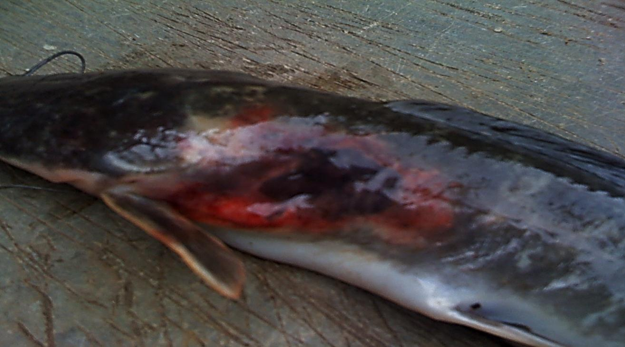

Figure 1: Fish from farm in Ikorodu with severe hyperaemic ulcers

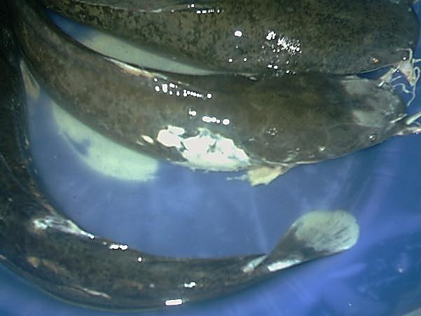

Fig 2: Fish from farm in Ikorodu with pustules and ulceration of the musculature, and necrosis of the tail fin and parietal part of the head

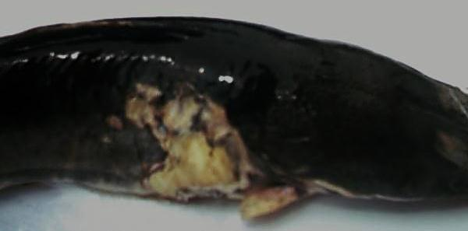

Fig 3: Fish from farm in Ibadan showing hyper-pigmentation, severe ulceration and necrosis of the skin and musculature

**Discussion**

Fish is an important source of protein. Fish farming involves rearing fish in a controlled environment. In Nigeria, the main factors affecting fish farming are high cost of production, lack of technical know-how (limited veterinarian and fish health expert), fish diseases, floods, water pollution, problem of preservation and lack of loans and grants. (15). Fish farming in Nigeria is an emerging industry and unlike our counterparts in the developed countries (19).

Awareness of fish diseases may not be high among fish farmers hence most cases of disease outbreaks are not reported. Most fish disease cases in Nigeria occur as a result of poor management practice especially poor water quality. In addition, the lack of biosecurity measures contribute to disease outbreak in farms as most brood stock were not being screened for diseases but are directly introduced into ponds. There are no policies yet to monitor fish farms. The catfish industry utilizes the services of veterinarians on limited basis as fish farmers tend to provide treatment themselves. In U.S.A only three antibiotics have been approved for use in catfish: Romet-30® (Sulfadimethoxine and Ormetoprim), Terramycin® (oxytetracycline) and Aquaflor® (florfenicol) (18).

In addition, for­malin, which is used to control protozoan parasites, is also approved for use but in Nigeria there are no regulations or monitoring of drugs in use for fish farming. Disease conditions in fish are of public health importance both in terms of physical wellbeing and productivity. Economically, aquaculture provides means of livelihood to farmers. In this study, it was observed that about 54.2% of respondents were male and 45.8% were female. The higher male representation in aquaculture was in agreement with the earlier findings in Ogbia and Yenagoa Local Government Areas Bayelsa State, Nigeria (19) where 80.3% of respondents were male and 19.7% were female. However, in this study it can be deduced that more women were now embracing aquaculture. This could be due to increase in awareness of aquaculture being profitable hence serving as a viable source of income.

The claim of operating on a large scale production by a majority (72.7%) of respondents was contrary to earlier (1, 18) in which a majority of fish farmers operated on a small scale production basis. However, this assertion to large scale production could be a claim directly linked to perceived status symbol attained by the fish farmers. The fact that most disease cases occurred during the juvenile stage could be because the fish were obtained from hatcheries at this stage and, the change of environment and the low immune status of fish at this age coupled with the stress of transportation could be predisposing them to disease. The study also revealed that most cases of disease outbreaks occurred during the dry season. This could be due to the lower availability and poor quality of water during this period, unlike the rainy season, when there is regular infusion of rain water into the ponds thereby improving the water quality.

There were many symptoms of diseases were identified by fish farmers though at different ratios. The most observed symptoms include: body wounds/ sores/lesions (93.9%), fish floating upside down due to loss of balances (91.7%) and stunted growth (85.1%). The least observed symptom was reddening of corners of the mouth and buccal cavity (26.7%). From this survey it was obvious that Nigeria’s aquaculture industry was already dealing with disease issues.

Majority of respondents reported that the highest occurrence of disease was in the recirculatory system. This could be due to lack of technical know-how in the operation of the culture system, poor maintenance culture and farmers attempting to cut cost. The culture system with the least occurrence of disease was the earthen pond. This might be due to low stocking density associated with earthen ponds.

In conclusion, there were many observed symptoms of diseases by fish farmers in Nigeria implying that fish diseases could be a major constraint for achievement of profitable aquaculture potential. Therefore more studies needed to be done to identify the diseases affecting the fish so that control measures can be instituted.

**Acknowledgment**

The authors would like to express their appreciation to The Fish Disease Diagnostic Laboratory of the Department of Veterinary Public Health and Preventive Medicine, University of Ibadan, Nigeria, University of Ibadan Fish Farm, Oyo State Fish farmers Association, Ikorodu Fish Farmers.

**References**

1. **Fagbenro, O.A., Akinbulumo, M.A., Ojo,S.O 2004.** Aquaculture in Nigeria: History and Prospects, *W. Aqua*, **35(2):** 21p.
2. **FAO 2000.** Aquaculture development beyond 2000. The Bangkok Declaration and strategy. Conference on Aquaculture development in the third Millennium 20-25 Feb 2000, Bangkok, Thailand.
3. **FAO,2006** Fisheries Management in the Federal Republic of Nigeria. [www.fao.org/fi/fep/en/NGA/body](http://www.fao.org/fi/fep/en/NGA/body).
4. **FAO,2008.** Fisheries and aquaculture statistics, FAO 2008 year book FAO publication.
5. **Francis- Floyd, R. 2003.** Introduction to Fish Health Management .CIR921. Florida. Original publication date February, 1990. Reviewed July, 2003. Minor revision July, 2005. <http://edis.ifas.ufl.edu>.
6. **Francis-Floyd, R. 2009** Stress- Its role in fish diseases. CIR919 series of fisheries and aquatic science department, Florida Cooperative Extension Service, Institute of Food and Agricultural Sciences, University of Florida. <http://edis.ifas.ufl.edu>
7. **Winton, J. R 2001**. Fish Health Management pp 559-640 in Wedemeyer, G(ed) [www.fishwashington.edu](http://www.fishwashington.edu)
8. **Fisheries Victoria Research Report, 2005a**. Fish Health Management Guidelines for farmed Murray Cod. Department of Primary Industries Victoria Australia ,Series No.32 2011 <http://www.dpi.vic.gov.au/fishing>
9. **Fisheries victoria research report 2005b**. Fish Health Management Guidelines for farmed Murray Cod. Fisheries victoria research report series- no 32 December 2005. Department of Primary Industries. [www.dpi.vic.gov.au/fisheries/aquaculture](http://www.dpi.vic.gov.au/fisheries/aquaculture)
10. **Dvorak Glenda, 2009** Biosecurity in Aquaculture Facility in North Central Region. North central Regional Aquaculture center Fact sheet #115 USDA grant #2007-38500-18569.
11. Maplandia.com google maps world gazetteer. Ibadan Map. <http://www.maplandia.com/nigeria/oyo/ibadannorth/ibadan/>
12. Maplandia.com google maps world gazetteer. Ikorodu Map. <http://www.maplandia.com/nigeria/lagos/ikorodu/ikorodu/>
13. The Fish Site. [www.thefishsite.com/articles/43/fish-diseases-in-aquaculture](http://www.thefishsite.com/articles/43/fish-diseases-in-aquaculture)
14. **Lee, C,S., O’Bryen P.J. 2003**. Biosecurity in Aquaculture production system: Exclusion of pathogen and other undesirables. The world Aquaculture Society, Baton Rouge, Louisiana USA 293pp.
15. **Grema H,G. Geidam Y. A. Egwu G. O 2011**. Fish Production in Nigeria: An update *NVJ* **32( 3)**
16. **Bolorunduro, P.I. Jegede O.C. Annatte, A.I. 2005**. Ethno- veterinary practise in pond disease prevention and control by fish farmers in Niger State Nigeria. *J Nat. Dev.* **3(2):**19-23.
17. **Patil,R jeyasekaran,G Shanmugam,S.A., Jeya Shakila, R. 2001.** Control of bacterial pathogens, associated with Fish diseases. *Ind. J. Mar. Stud.* **3(4):** 264-267*.*
18. **Merck Veterinary manual**. Management of fish. [www.merckmanuals.com](http://www.merckmanuals.com)
19. **Adeyemo, A. O 2011** Fishdiseases symptoms as observed by fish farmers in Ogbia and Yenagoa Local Government Areas Bayelsa State, Nigeria*. J. Agric. Vet. Sci.* **3:**13-19.