

Africa Journal of Animal and Biomedical Sciences **8(1**), 2014

ISSN: 1819-4214

©INABSTA

**Reliability of using Best’s Carmine and Haematoxylin-Eosin methods for the detection of glycogen in paraffin wax tissue sections.**

**L.D. Nabbale1, S.Kalungi 1, G.S.Bimenya 1, E. Othieno 1, A.L. Okwi 1*.**

1. Department of Pathology, School of Biomedical Sciences, College of Health Sciences,

Makerere University, P.O.Box7072 Kampala, UGANDA

*Corresponding e-mail: [livexo@yahoo.co.uk](mailto:livexo@yahoo.co.uk), [andrewol@chs.mak.ac.ug](mailto:andrewol@chs.mak.ac.ug); Tel: +256 772 481887

**Abstract**

The study sought to determine the reliability of Heamatoxylin and Eosin (H&E) and Best’s carmine methods for the detection of glycogen in paraffin wax embedded tissues sections. This was a retrospective laboratory based study. Tissue blocks of adenocarcinoma of the ovary were retrospectively retrieved, sectioned and stained using H&E and Best’s carmine as test methods and periodic acid-Schiff (PAS) as “gold standard”. Out of 200 tissues sampled, 60.5% were PAS positive.. Based on the performance of “gold standard” (PAS), Best’s carmine and H&E had sensitivities of (88.5%; 56%) and specificities of (69.9%; 44%) respectively. Best’s carmine had positive and negative predictive values of (69.4%; 88.8%) respectively, while H&E had positive and negative predictive values of (45.5%; 54.6%) respectively. Best’s carmine had diagnostic accuracy of 78.6% and H&E 49.5%. Best’s carmine had Cohen’s kappa of 0.6 while H&E had 0.001. PAS had turn- around time (TAT) of 858 minutes, costing USD 1.17 per test, while Best’s carmine TAT of 107 minutes costing USD 1.65 per test. H&E had TAT of 65 minutes costing USD 1.21 USD per test. Exchange rate of 1 USD = Ug. Shs 2509.**.**Best’s carmine had fairly high reliability, high TAT and fairly costly. H&E had low reliability, low TAT and fairly cheaper. PAS had highest reliability and highest TAT and very cheap. Although Best’s carmine had high TAT and fairly expensive, it would be the most preferred method in the absence of PAS.

**Key words:** Reliability, Best’s Carmine, Haematoxylin, Periodic acid.

**Introduction**

Demonstration of glycogen is today very important in the diagnosis of diseases such as Von Gierke’s disease, Pompe’s disease, diabetes mellitus and malignant conditions (1,2,3). Although H&E is the most commonly used technique for demonstration of tissue structures, this method does not specifically demonstrate glycogen (4). While special staining methods such as periodic acid-Schiff’s and Best’s carmine are today being used for demonstration of glycogen (4,5,6,7), their use has not been much popularised in the Department of Pathology, School of Biomedical Sciences, College of Health Sciences, Makerere University, Kampala, Uganda.

The intensity of the staining by PAS has been linked to the type of muco-substance stained. For example, glycogen and other types of mucin have been found to stain strongly with the PAS method, while basement membranes and collagen have been found to stain less strongly with cartilage and mast cells staining weakly and times not at all (8). Some studies have found that certain molecular mechanisms such as dye molecule attraction to substrates, play a role in tissue staining. Basic dyes such as PAS are believed to diffuse into the tissue sections and are attracted towards negatively charged groups of macromolecules such as phosphate of nucleic acids. Besides pH of the staining solution has equally been found to influence the intensity of staining by some of these dyes ( 9, 10).

The use of PAS in particular poor resource communities is yet to be popularised because PAS requires low temperature storage of its reagents (11) thus making it unreliable in settings such as Uganda with inconsistent power supply. In addition, the reliability of H&E and Best’s carmine to Periodic acid remains unknown in the Department of Pathology, School of Biomedical Sciences, College of Health Sciences, Makerere University, Kampala, Uganda.

This study was therefore conducted with primary aim of determining the reliability, ease of applicability and cost of using either H&E or Best’s carmine as alternative method to PAS for the detection of glycogen in formalin fixed and paraffin wax embedded tissue sections in settings with either no power supply or have unreliable power supply.

**Methods and materials**

This was retrospective laboratory based study. carried out in the Department of Pathology, School of Biomedical Sciences, College of Health Sciences, Makerere University, Kampala, Uganda.. Permission to use the archival tissue samples was sought from the Department of Pathology.

The sample size of 200 used for reliability studies was calculated using the standard graphs based on the assumption that at 95% confidence interval, the expected reliability of detection of glycogen was 0.05 (12). Therefore this samples size was used to determine the sensitivity, specificity, diagnostic accuracy, likelihood ratio of positive and negative test, diagnostic odds, and Kappa test of Best,s carmine and H&E methods.

The 200 biopsy tissue blocks from Department of Pathology archives were randomly collected from the blocks diagnosed with carcinoma of the ovary between January 2003 to April 2006. The negative control cases of adenocarcinoma of the ovary were purposively obtained from post mortem blocks.

All the selected paraffin embedded tissue blocks were re-blocked and three sections 5 micron thickness were cut from each block. One section from each block was stained by each of the methods namely: PAS method (“gold standard”) whose known protocol was adopted (4) and Best’s carmine and H&E test methods whose known protocols were adopted (4, 5). This included one negative control section. For purpose of quality assurance, the knife was cleaned before cutting or sectioning the next block.

All the cases stained magenta colour by PAS were taken as positive for glycogen, while those that stained deep-light brown by Best’s carmine were considered as positive. The cases that stained light pinkish by H$E were interpreted as positive for glycogen. Photo-micrographs of positive cases were taken.

The costs of performing the tests was determined on the assumption that the people performing the tests were paid monthly salary and were therefore performing routine work. It was also assumed that: space, electricity and water would not be included in the cost since they are already provided under infrastructure.

Determination of ease of applicability of methods was done by measuring Turn Around Time (TAT). TAT was taken as time taken to prepare stock and /or working solutions including time taken to perform the test and making final report.

The data was entered and analysed using soft-ware package for social science 10.0 (SPSS 10.0) (13) The open source epidemiologic statistic programme for public health version 2.2.1 (Openepi) (14) was used for the comparison of these methods at 95% confidence interval. The sensitivity, specificity and predictive values were calculated using the formulae given by Trap and Dawson (15)**.** The results were presented in form of tables and photo-micrographs.

**Results**

Out of 200 tissues sampled analysed, PAS had 121 (60.5%) true positive and 79 true negative cases. Best’s carmine had 79 (39.5%) true positive and 77 (38.5%) true negative cases. It had 10 (5%) false positive and 34 (17%) false negatives cases. H&E had 51 (25.5%) true positive and 48 (24%) true negative cases and it had 40 (20%) false positive and 61(30.5%) false negatives cases. The measure of the performance by Best’s carmine and H&E was based on the performance of “gold standard” (PAS). The sensitivities, specificities, positive and negative predictive values, diagnostic accuracies and Cohen’s kappa scores of Best’s carmine and H&E were as shown in Tables 1 and 2.

A total of Ug Shs 587,000 (an equivalent of USD 234.8 at exchange rate of IUSD = Ug Shs 2509) would be incurred on buying materials and chemicals for PAS and cost per test would be Ug Shas 2,935 UGSh (1.17 USD). The details of the costs were as as shown in Table 4.

A total of Ug Shs 827,000 (330.8 USD) would be incurred on buying materials and chemicals for Best’s carmine method and cost per test would be Ug Shs 4,135 (USD 1.65). The details of the costs were as as shown in Table 5.

A total of Ug Shs 607,000 (USD 242.8) would be incurred on buying materials and chemicals for H&E and cost per test would be Ug Shs 3,035 (USD 1.21). The details of the costs were as as shown in Table 5.

The Figures 1, 2, and 3 below are the photomicrographs of an adenocarcinoma of the ovary stained by PAS, Bests’s carmine and H&E respectively. The arrows show positively stained glandular areas due to glycogen. Figures 4 and 5 show negative staining of one of the adenocarcinoma blocks by Bests carmine and H$E.

PAS had TAT of 858 minutes, while Best’s carmine had TAT of 107 minutes and H&E had TAT of 65 minutes. The details were as shown in Table 3.

Table 1. Bests carmine method against PAS method (gold standard).

|  |  |  |
| --- | --- | --- |
| Parameter | Estimate | 95 % CI |
| Sensitivity | 88.5% | (80.1, 93.6) |
| Specificity | 69.9% | (60.9, 77.6) |
| +ve predictive value | 69.4% | (60.3, 77.2 |
| -ve predictive value | 88.8 | (80.5, 93.8) |
| Diagnostic accuracy | 78.6% | (71.7, 83.2) |
| Likelihood ratio of positive test | 2.94 | (27.7, 3.1) |
| Likelihood ratio of negative test | 0.2 | (0.1-0.2) |
| Diagnostic Odds | 17.8 | (8.3-38.7) |
| Cohen’s kappa | 0.6 | (0.4-0.7) |

Table 2. Haematoxylin and eosin (H&E) method against PAS method (gold standard).

|  |  |  |
| --- | --- | --- |
| Parameter | Estimate | 95 % CI |
| Sensitivity | 56% | 45.8, 65.8 |
| Specificity | 44.0% | 35.1, 53.4 |
| +ve predictive value | 45.5% | 36.6, 54.8 |
| -ve predictive value | 54.6% | 44.2, 64.5 |
| Diagnostic accuracy | 49.5% | 42.7, 56.4 |
| Likelihood ratio of positive test | 1.0 | 0.9, 1.1 |
| Likelihood ratio of negative test | 0.99 | 0.9, 1.1 |
| Diagnostic Odds | 1.0 | 0.5, 1.8 |
| Cohen’s kappa | 0.001 | (0.1-0.1) |

Table 3. Turn around time (TAT) in minutes of H&E and Bests carmine.

|  |  |  |  |  |
| --- | --- | --- | --- | --- |
| Method | Preparation of stock solution(s) | Preparation of  working solution | Performance protocol including reading of  Results | Total |
| PAS | 13 hrs (780 minutes) | 30 minutes | 48 minutes | 858 minutes |
| Best Carmine | 55 minutes | 7 minutes | 45 minutes | 107 minutes |
| H&E | 30 minutes | - | 35 minutes | 65 minutes |

Table 4. The costs in Ug Shs and USD incurred when using by PAS method.

|  |  |  |  |  |
| --- | --- | --- | --- | --- |
| Item | Cost in UGSh | Sub-total | Cost in USD  (*Equivalent) | Sub-total |
| Haematoxylin 25 g | 65,000 | 65,000 | 26 | 26 |
| Periodic acid 100g | 85,000 | 85,000 | 34 | 34 |
| Basic fuchsin | 35,000 | 35,000 | 14 | 14 |
| Xylene 2.5 Litres | 50,000 | 50,000 | 20 | 20 |
| Potassium metabisulphite (500 g) | 25,000 | 25,000 | 10 | 10 |
| Activated charcoal 250 g | 35,000 | 35,000 | 14 | 14 |
| Whatman filter paper | 80,000 | 80,000 | 32 | 32 |
| Eosin 25 g | 70,000 | 70,000 | 28 | 28 |
| Isopropyl 2.5 Litres | 50,000 | 50,000 | 20 | 20 |
| Slides 2 pkts (100 slides each) | 12,000 | 12,000 | 4.8 | 4.8 |
| Cover slips 2 pkts (100 cover slips each | 10,000 | 10,000 | 4 | 4 |
| DPX | 70,000 | 70,000 | 28 | 28 |
| Overall total | 587,000 | 587,000 | 234.8 | 234.8 |
| Cost per test | 2,935 UGSh | | 1.17 US$ | |

Table 5: The costs in Ug Shs and USD incurred when using by Best’s carmine method

|  |  |  |  |  |
| --- | --- | --- | --- | --- |
| Item | Cost in UGSh | Sub-total | Cost in USD  (*Equivalent ) | Sub-total |
| Potassium chloride 100 g | 70,000 | 70,000 | 28 | 28 |
| Potassium carbonate 100g | 70,000 | 70,000 | 28 | 28 |
| Carmine 100g | 65,000 | 65,000 | 26 | 26 |
| Concentrated ammonia 1 Litre | 85,000 | 85,000 | 34 | 34 |
| Methanol 1 Litre | 10,000 | 10,000 | 4 | 4 |
| Ethanol 2.5 Litres | 40,000 | 40,000 | 16 | 16 |
| Slides 2 packets | 12,000 | 12,000 | 4.8 | 4.8 |
| Cover slip 2 packets | 10,000 | 10,000 | 4 | 4 |
| Mercuric oxide 25g | 120,000 | 120,000 | 48 | 48 |
| Potassium alum 500 g | 70,000 | 70,000 | 28 | 28 |
| Glacial acetic acid 2.5 Litres | 50,000 | 50,000 | 20 | 20 |
| Haematoxylin 25 g | 65,000 | 65,000 | 26 | 26 |
| Absolute alcohol 1 Litre | 40,000 | 40,000 | 16 | 16 |
| Xylene 2.5 Litres | 50,000 | 50,000 | 20 | 20 |
| DPX 500 mls | 70,000 | 70,000 | 28 | 28 |
| Overall total | 827,000 UgSh | 827,000 UgSh | 330.8 | 330.8 |
| Cost per test | 4,135 UGSh | | 1.65 US$ | |

Table 6. The costs in Ug Shs and USD incurred when using H&E method.

|  |  |  |  |  |
| --- | --- | --- | --- | --- |
| Item | Cost in UGSh | Sub-total | Cost in USD  (*Equivalent) | Sub-total |
| Haematoxylin 25 g | 65,000 | 65,000 | 26 | 26 |
| Absolute alcohol 1 Litre | 40,000 | 40,000 | 16 | 16 |
| Xylene 2.5 Litres | 50,000 | 50,000 | 20 | 20 |
| Potassium alum 500 g | 70,000 | 70,000 | 28 | 28 |
| Mercuric oxide 25 g | 120,000 | 120,000 | 48 | 48 |
| Glacial acetic acid 2.5 Litres | 50,000 | 50,000 | 20 | 20 |
| Eosin 25 g | 70,000 | 70,000 | 28 | 28 |
| Isopropyl 2.5 Litres | 50,000 | 50,000 | 20 | 20 |
| Slides 2 pkts | 12,000 | 12,000 | 4.8 | 5 |
| Cover slips 2 pkts | 10,000 | 10,000 | 4 | 4 |
| DPX | 70,000 | 70,000 | 28 | 28 |
| Overall total | 607,000 | 607,000 | 242.8 | 242.8 |
| Cost per test | 3,035 UGSh | | 1.21 USD | |

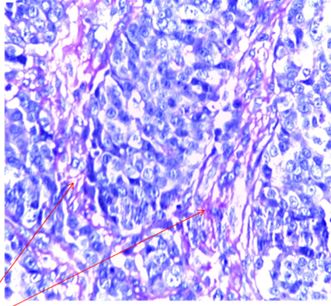

Figure 1: Magenta stained glands of adenocarcinoma of the ovary by PAS due to glycogen (see arrow) x 40 magnification.

Figure 2: Deep light brown stained glands of adenocarcinoma of the ovary by Best’s carmine due to glycogen (see arrow) x 40 magnification

Figure 3. Light pink stained glands of adenocarcinoma of the ovary by H&E of the ovary due to glycogen (see arrow) x 40 magnification**.**

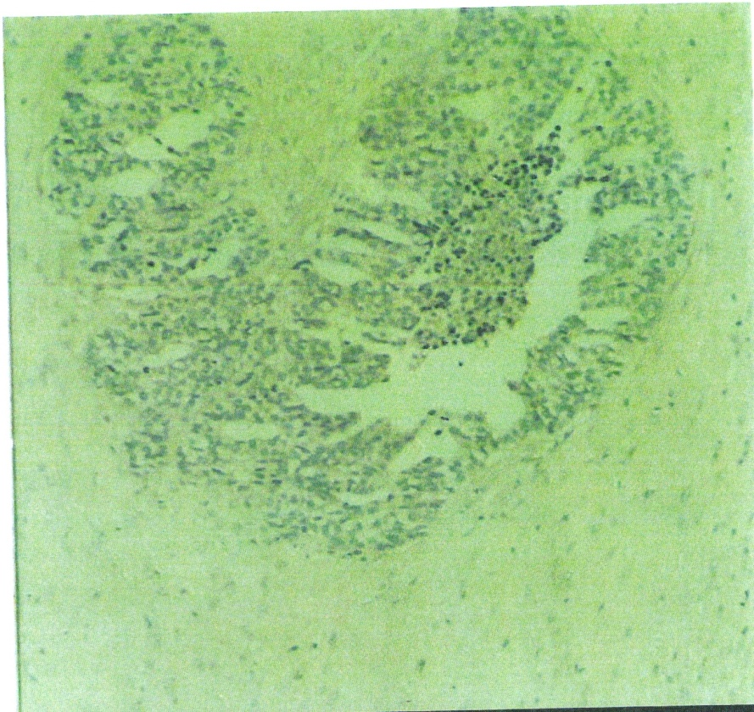

Figure 4. Negative staining by Best’s carmine of adenocarcinoma of the ovary**.**

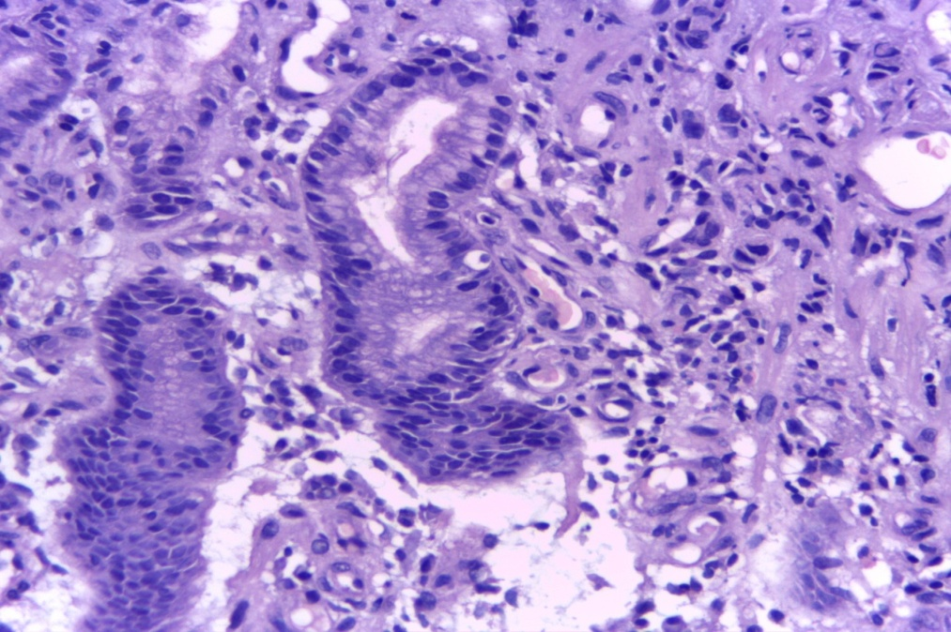

Figure 5. Negative staining of adenocarcinoma of the ovary by haematoxylin and eosin

method.

**Discussion**

There was variability in the detection of glycogen in various tissue samples by Best’s carmine and H&E methods, with H&E having very low reliability, sensitivity, specificity, diagnostic accuracy and Cohen’s kappa (Table 2) as compared to Best’s carmine which had relatively high sensitivity, specificity, diagnostic accuracy and Cohen’s kappa (Table 1). H&E method was in particular associated with high false negative rates which is characteristic of a method with low specificity and diagnostic accuracy. These findings were in agreement with earlier study (4) where it was noted that cells containing abundant glycogen stained weakly (false negatively) with eosin component of the H&E method compared to those with little glycogen.. The high false negative rate by H&E was probably due to background staining by the counter stain (eosin) and due to poor differentiation by washing.

Although Best’s carmine was expected to stain glycogen with intense bright red colour, it was found that all the positive cases probably due to glycogen stained light pinkish brown colour (Figure 2). This was probably due to poorly uncontrolled differentiation leading to over differentiation of carmine. Secondly, it could have been due to excessive use of heat during tissue processing and staining which may have affected the carmine configuration and thus glycogen binding to carmine. This was in agreement with the findings by Dapson (16) who noted that destruction of carmine by heat could have negative effect on the quality of glycogen staining by Best’s carmine, since glycogen binds to carmine through hydrogen bonding. This was also in conformity with [Horobin](http://www.springerlink.com/content/?Author=R.+W.+Horobin) and  [Murgatroyd](http://www.springerlink.com/content/?Author=L.+B.+Murgatroyd) (17) who noted that the variation in the intensity of glycogen staining by Best’s carmine is due to stereochemistry related to hydrogen bonding.

It was also possible that since our tissues were fixed in 10% un-buffered formalin and at room temperature, this could have affected the intensity of glycogen staining by Best’s carmine. This was in conformity by Zakout et al (18) who found that the quality of glycogen staining by Best’s carmine was sensitive to both fixation and temperature.

Based on the time taken to prepare the solutions (stock and working) and staining, both Best’s carmine and PAS methods were found to be associated with high TAT as compared to H$E (Table 3). The most likely reason for this difference was that Best’s carmine needed preparation of two stock solutions and one working solution thus rendering it lengthy method, while preparation of PAS staining found cumbersome and took a very long time with some of the reagents requiring incubation for overnight before filtering. Notably, Best’s carmine was found to be fairly more expensive (Table 5) than both H&E (Table 6) and PAS (Table 4). The reason for this difference was probably due to many reagents that are required in preparation of Best’s carmine solutions.

However, this study had some limitations in that it did not use enzyme diastase for confirmation of glycogen detection by these methods. So the results were therefore based on the assumption that all the positive staining by these methods was probably due to glycogen. Secondly, although the micrometer was set at 5 microns, it was not possible to ascertain whether the sections cut were indeed 5 microns. So the thickness of our sections could have affected on the quality of staining by these methods.

In conclusion the Best’s carmine had fairly high reliability though it had high TAT and was expensive. Although H&E had low TAT and was fairly cheaper, it had low reliability. In the absence of PAS, Best’s carmine would be the most recommended method for detection of glycogen in paraffin wax embedded tissue sections because of its high reliability

**Acknowledgement**

We thank the Department of Pathology, Department of Pathology, School of Biomedical Sciences, College of Health Sciences, Makerere University, Kampala, Uganda for granting us permission to use the archives. We thank Dr. Kitahubwa Peter and Dr. Munema Asafu for their contributions and all the technical staff for their support.

**References**

**1.** [**van de Werve, G**](http://www.ncbi.nlm.nih.gov/pubmed?term=%22van%20de%20Werve%20G%22%5BAuthor%5D)**.,** [**Lange, A**](http://www.ncbi.nlm.nih.gov/pubmed?term=%22Lange%20A%22%5BAuthor%5D)**.,** [**Newgard, C**](http://www.ncbi.nlm.nih.gov/pubmed?term=%22Newgard%20C%22%5BAuthor%5D)**.,** [**Méchin, M.C**](http://www.ncbi.nlm.nih.gov/pubmed?term=%22M%C3%A9chin%20MC%22%5BAuthor%5D)**.,** [**Li, Y**](http://www.ncbi.nlm.nih.gov/pubmed?term=%22Li%20Y%22%5BAuthor%5D)**.,** [**Berteloot, A**](http://www.ncbi.nlm.nih.gov/pubmed?term=%22Berteloot%20A%22%5BAuthor%5D). **2000.** New lessons in the regulation of glucose metabolism taught glucose-6-phosphate system. *Eur J Biochem.* **267:** 1533-1549.

**2 . Hiraiwa, H.*,* Pan, C.J., Lin, B., Moses, S.W., Chou. J.Y. 1999.**  Inactivation of the glucose-6-phosphate transporter causes glycogen storage disease type Ib. *J Biol Chem*., **274:** 5532-5536.

**3.** [**Talente**](http://pubget.com/search?q=authors%3A%22G%20M%20GM%20Talente%22)**, G.M.,**  [**Alter**](http://pubget.com/search?q=authors%3A%22C%20C%20Alter%22)**, C.C.,**  [**Baker**](http://pubget.com/search?q=authors%3A%22L%20L%20Baker%22) **LL,** [**et al.**](http://pubget.com/search?q=authors%3A%22B%20I%20BI%20Brown%22)  **1994.** Glycogen storage disease in adults*.* [*Ann Intern Med*](http://pubget.com/search?q=latest%3AAnnals+of+Internal+Medicine&from=8273986). [**120(3)**:218-26](http://pubget.com/search?q=issn%3A0003-4819+vol%3A120+issue%3A3&from=8273986).

**4. Barbara, A.T., Mucins in: Bancroft, J.D., Marilyn, G. 2002.** *Theory and practice of histological techniques*. Harcourt Publishers Limited USA. 172-176.

**5. Culling, C.F.A. 1974.** A handbook of histopathological and histochemical techniques. 3rd edition Dunn Butterworth, London UK.

**6. Bancroft, J.D., Cook, H.C. 1984.**. *Manual of Histological techniques*. 1st edition Churchill Livingstone New York USA.

**7.** [**Williams, D.L**](http://www.ncbi.nlm.nih.gov/pubmed?term=Williams%20DL%5BAuthor%5D&cauthor=true&cauthor_uid=9883090)**,** [**Hopcroft, T**](http://www.ncbi.nlm.nih.gov/pubmed?term=Hopcroft%20T%5BAuthor%5D&cauthor=true&cauthor_uid=9883090)**.,** [**Pantel, U**](http://www.ncbi.nlm.nih.gov/pubmed?term=Pantel%20U%5BAuthor%5D&cauthor=true&cauthor_uid=9883090)**.,** [**Brancker, W.M**](http://www.ncbi.nlm.nih.gov/pubmed?term=Brancker%20WM%5BAuthor%5D&cauthor=true&cauthor_uid=9883090)**. 1998**. Levels of choroidal body carbonic anhydrase activity and glycogen in farmed halibut. [*Vet J.*](http://www.ncbi.nlm.nih.gov/pubmed/9883090)*,* **156(3):**223-229.

**8. Kiernan, J.A. 2010.** Carbohydrate histochemistry*.* Connection (Dako Inc. Scientific Magazine) **14:** 68-78.

**9. Dapson, R.W.** **2005.** Dye-tissue interactions: mechanisms, quantification and bonding parameters for dyes used in biological staining. *Biotech Histochem*.**80(2):**49-7

**10. Prento, P.** Staining of macromolecules: possible mechanisms and examples. Biotech Histochem2009; 84(4):139-158.

**11.** [**Fairchild, T.J**](http://www.ncbi.nlm.nih.gov/pubmed?term=Fairchild%20TJ%5BAuthor%5D&cauthor=true&cauthor_uid=15570139)**.,** [**Fournier, P.A**](http://www.ncbi.nlm.nih.gov/pubmed?term=Fournier%20PA%5BAuthor%5D&cauthor=true&cauthor_uid=15570139)**. 2004.** Glycogen determination using periodic acid-Schiff: artefact of muscle preparation. [*Med Sci Sports Exerc*.](http://www.ncbi.nlm.nih.gov/pubmed/15570139) **36(12):** 2053-8.

**12. Browner, J.W., Newman, T.B., and Cummings, S.R. 1988.** Prevalence of prior probability and predictive value. Designing clinical research on epidemiological approach 1st edition. William and Wilkins USA. 90-91.

13**. SPSS 2000**. Advanced Statistics 10.1. Inc. of Chicago, Illinois, USA.

14. **Anonymous, 2008**. Open Source Epidemiologic Statistics fro Public Health Version 2.2.1

[http://www.openepi.com/Menu/EpiMenu.htm. Accessed on 6th April 2008](http://www.openepi.com/Menu/EpiMenu.htm.%20Accessed%20on%206th%20%20April%202008)

**15. Dawson, B., Trapp, R.G 2001**. *Basic and Clinical Biostatistics*. 3rd edition

Lange Medical Books/McGraw-Hill Medical Publishing Division. New York USA.

**16. Dpason, R.W. 2007.** The history, chemistry and modes of action of carmine and related dyes. *Biotech Histochem*. **82(4):**173-87.

**17.** [**Horobin**](http://www.springerlink.com/content/?Author=R.+W.+Horobin)**, R.W.,** [**Murgatroyd**](http://www.springerlink.com/content/?Author=L.+B.+Murgatroyd)**, LB.** **1971.** The staining of hydrogen with Bests carmine and similar hydrogen bonding dyes. A mechanistic study. The Histochemical Journal **3(1):** 1-9 DOI: 10.1007/BFO1686501

**18.** [**Zakout, Y.M**](http://www.ncbi.nlm.nih.gov/pubmed?term=Zakout%20YM%5BAuthor%5D&cauthor=true&cauthor_uid=20214545)**.,** [**Salih, M.M**](http://www.ncbi.nlm.nih.gov/pubmed?term=Salih%20MM%5BAuthor%5D&cauthor=true&cauthor_uid=20214545)**.,** [**Ahmed, H.G**](http://www.ncbi.nlm.nih.gov/pubmed?term=Ahmed%20HG%5BAuthor%5D&cauthor=true&cauthor_uid=20214545)**. 2011**. The effect of fixatives and temperature on the quality of glycogen demonstration. Biotech Histochem., **86(6):** 448.